Road Accident Report Using SQL

- Current Year Casualties
SELECT SUM(number_of_casualties) CY_Casualties
FROM road_accident
WHERE YEAR(accident_date)='2022';
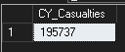

- Current Year Accidents
SELECT COUNT(accident_index) CY_Accidents
FROM road_accident
WHERE YEAR(accident_date)='2022';
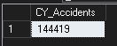

- Current Year Fatal Casualties
SELECT SUM(number_of_casualties)Fatal_Casualties
FROM road_accident
WHERE YEAR(accident_date)='2022' AND accident_severity='Fatal';
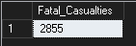
- Current Year Fatal Percentage
SELECT CAST(SUM(number_of_casualties) AS decimal (10,2))*100/(SELECT CAST(SUM(number_of_casualties)AS decimal (10,2)) FROM road_accident)AS Total_Casualties
FROM road_accident WHERE accident_severity='Fatal' AND YEAR(accident_date)='2022';
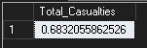

- Accidents By Vehicle Type
SELECT Type,SUM(number_of_casualties)Casualties FROM
(SELECT *, CASE WHEN vehicle_type IN ('Agricultural vehicle') THEN 'Agricultural' WHEN vehicle_type IN ('Car','Taxi/Private hire car') THEN 'Car' WHEN vehicle_type IN('Motorcycle 50cc and under','Motorcycle over 500cc','Motorcycle 125cc and under','Motorcycle over 125cc and up to 500cc','Pedal cycle') THEN 'Bike' WHEN vehicle_type in ('Minibus (8 - 16 passenger seats)','Bus or coach (17 or more pass seats)') THEN 'Bus' WHEN vehicle_type IN ('Van / Goods 3.5 tonnes mgw or under','Goods over 3.5t. and under 7.5t','Goods 7.5 tonnes mgw and over') THEN 'Van' Else 'Other' END AS Type FROM road_accident )
TEMP WHERE YEAR(accident_date)='2022' GROUP BY Type ORDER BY Casualties DESC ;
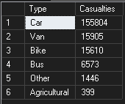

- Current Year Casualties By Month
SELECT DATENAME(MONTH,accident_date) AS Month,SUM(number_of_casualties) CY_Casulaties
FROM road_accident
WHERE YEAR(accident_date)='2022' GROUP BY DATENAME(MONTH,accident_date);
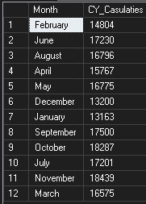

- Accidents By Road Type
SELECT road_type,SUM(number_of_casualties)CY_Casualties
FROM road_accident
WHERE YEAR(accident_date)='2022'
GROUP BY road_type
ORDER BY SUM(number_of_casualties) DESC;
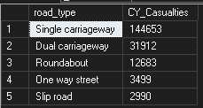

- Current Year Casualties by Urban vs Rural
SELECT urban_or_rural_area,CAST(SUM(number_of_casualties) AS decimal(10,2))*100/(SELECT CAST(SUM(number_of_casualties)AS decimal (10,2))AS TOTAL FROM road_accident WHERE YEAR(accident_date)='2022') Percentage
FROM road_accident WHERE YEAR(accident_date)='2022'
GROUP BY urban_or_rural_area;
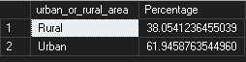

- Current Year Casulaties By Light vs Darkness
SELECT CASE WHEN light_conditions in ('Darkness - no lighting','Darkness - lights lit','Darkness - lighting unknown','Darkness - lights unlit') THEN 'Darkness' ELSE 'Light' END AS Light_Condition,CAST(SUM(number_of_casualties)AS decimal(10,2))*100/(SELECT CAST(SUM(number_of_casualties)AS decimal(10,2))FROM road_accident WHERE YEAR(accident_date)='2022')AS Percentage
FROM road_accident
WHERE YEAR(accident_date)='2022'
GROUP BY CASE WHEN light_conditions in ('Darkness - no lighting','Darkness - lights lit','Darkness - lighting unknown','Darkness - lights unlit') THEN 'Darkness' ELSE 'Light' END
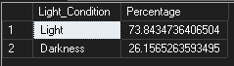

- Top 10 Cities with Casualties
SELECT TOP(10)local_authority,SUM(number_of_casualties)[TOTAL CASUALTIES] FROM road_accident GROUP BY local_authority ORDER BY SUM(number_of_casualties)DESC
